Old Christmas traditions
http://app.sliderocket.com/app/sliderocket.aspx#o
Created by Gabija ir Sonata

Lithuanian Christmas traditions are a combination of old and new, Christian and pagan, and they have similarities with traditions from the other two Baltic nations, as well as with the traditions of Poland, whose past is linked with Lithuania's.

In pagan Lithuania, the Christmas celebration as we know it today was actually the celebration of the winter solstice.
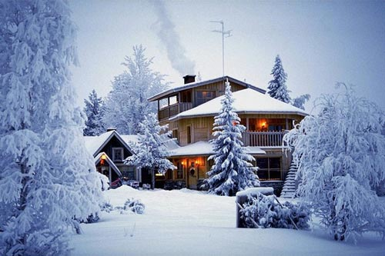
http://labho.com/wp-content/uploads/2011/09/winter.jpg
Roman Catholics, the predominant religious population in Lithuania, gave new meaning to old customs or introduced new ways to celebrate the religious holiday.

For example, some people say the practice of placing hay underneath the tablecloth on Christmas Eve predates the introduction of Christianity to Lithuania, though now obvious parallels can be drawn between hay on the Christmas table and the hay in the manger where Jesus was born.
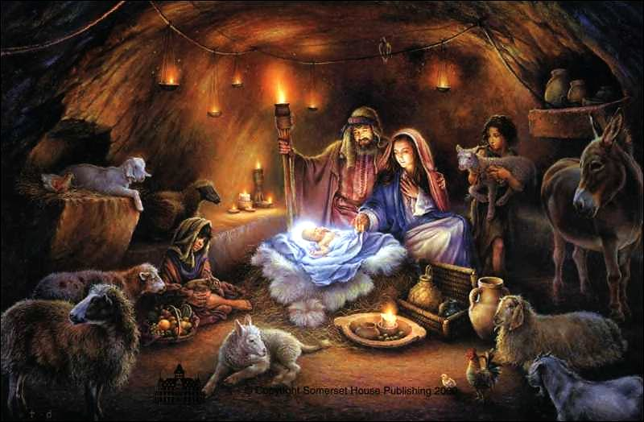
http://kaynou.files.wordpress.com/2010/12/nativity2.jpg
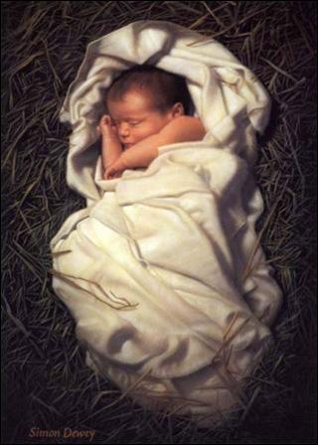
http://folkonfolks.com/wp-content/uploads/2010/12/SSC2.jpg
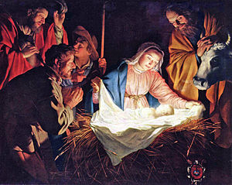http://www.bernardinai.lt/file/bf5b49859a997b75f47a409036fd8e26aa0ea9be_article.jpg
As in Poland, the Christmas Eve feast traditionally consists of 12 meatless dishes (though fish is permitted, and herring is often served). The breaking of religious wafers precedes the meal.
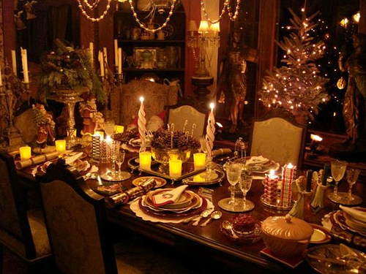 http://www.flickr.com/photos/rick_romer/3986216757/

An Old Christmas tree decorated with hand-made decorations. People prepared Christmas cookies and hung on the Christmas tree.
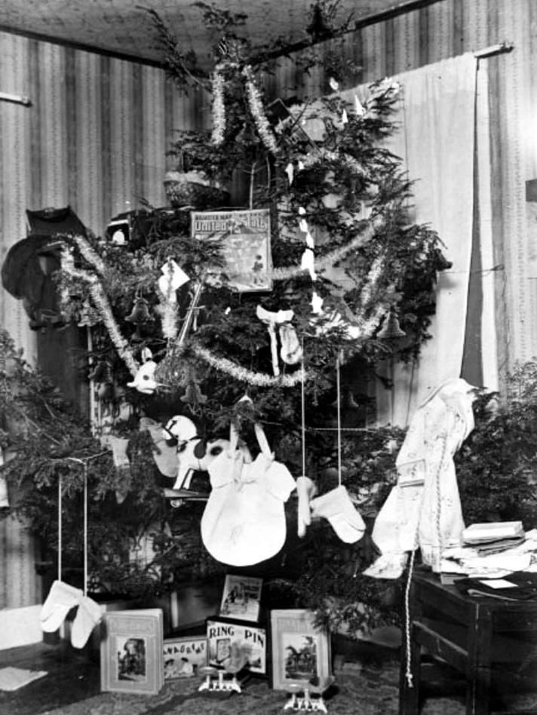 http://www.inherited-values.com/wp-content/uploads/2009/12/presents-on-christmas-tree-dated-1896.jpg
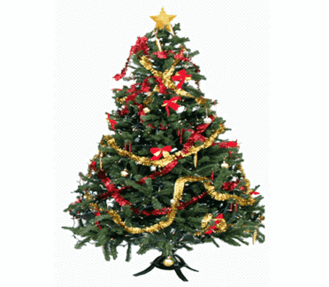
http://www.inhabitat.com/wp-content/uploads/agreenerchristmastree.gif

The text was taken from http://lt.wikipedia.org

