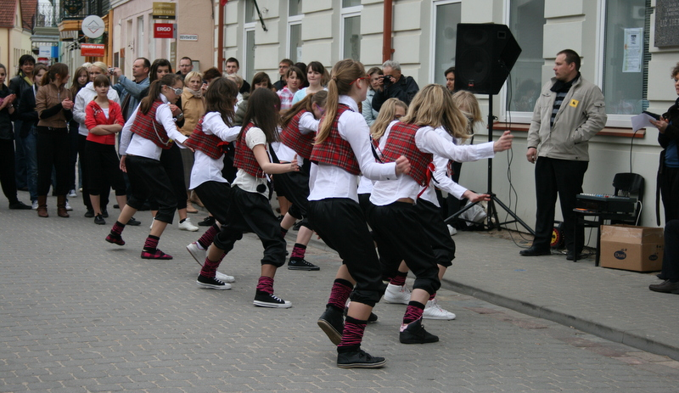
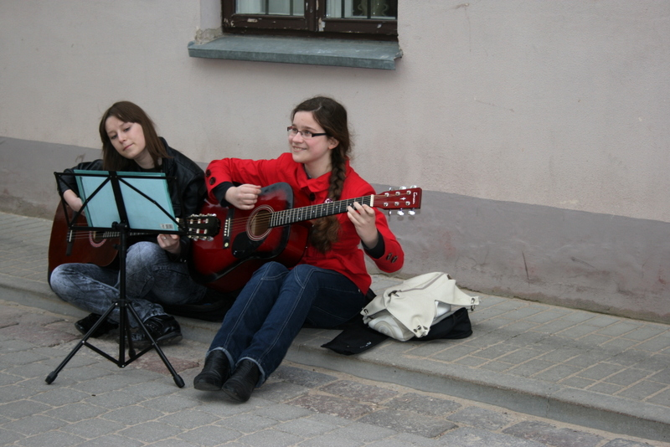
The only one day per year in Lithuania when many cities here are full of music sounds is the Street Music Day. It is a national festival inspired by one of the most appreciated Lithuanian musician Andrius Mamontovas. The idea was realized for the first time in 2007 and it became a wonderful tradition uniting all Lithuania with sounds of music in the streets.
Photo: Street Music Day in Kedainiai, by Arnis, GVC1114 Photo: Street Music Day in Kedainiai, by Arnis, GVC1114

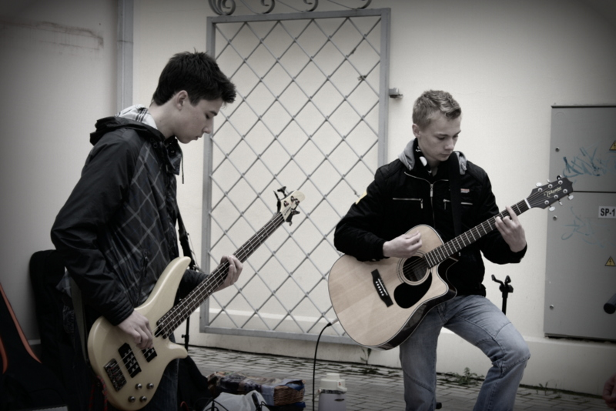
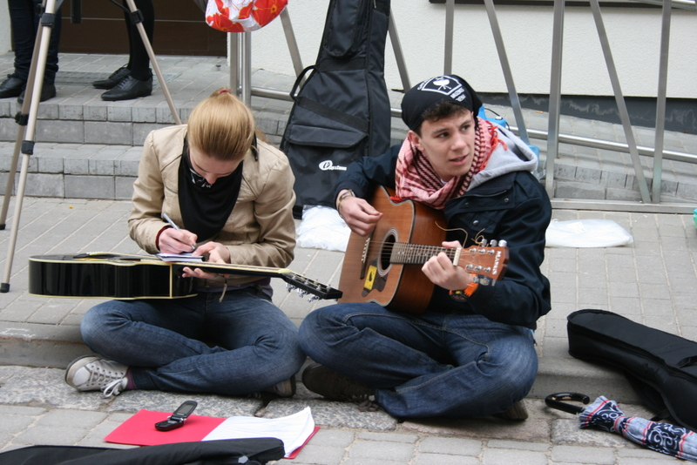
The first Saturday of May is the big day for all music lovers in Lithuania. Everybody who can sing, play or simply make some noise are welcome to go outside and fill the air with sounds. There are no any limits – it does not matter what is your age, nationality and a repertoire. According to the initiator of this fest Andrius Mamontovas, this day is a gift for Lithuania gifted by Lithuanians themselves without any blessing or financing by government. It is just a little miracle and fantastic atmosphere uniting everybody in one great celebration.
Photo: Street Music Day in Kedainiai, by Arnis, GVC1114 Photo: Street Music Day in Kedainiai, by Arnis, GVC1114

As for the first time in 2007 musicians came out to play only in Vilnius, later years the same scenery appeared in other biggest cities. In 2009 the festival spread all over Lithuania and every active municipality built perfect conditions for playing in the streets in their cities. More than 5000 musicians were shaking an air with sounds of music in all Lithuania. In 2010 organizers of the festival expect to attain even more participants.
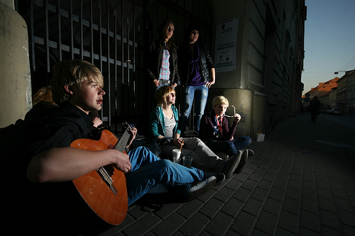

Photo: from httpwww.flickr.comphotosen-t3496079075

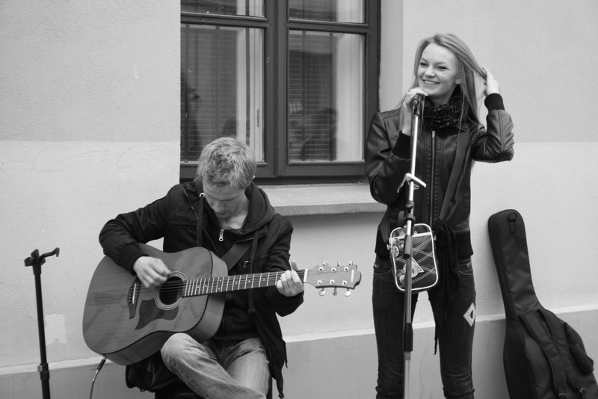
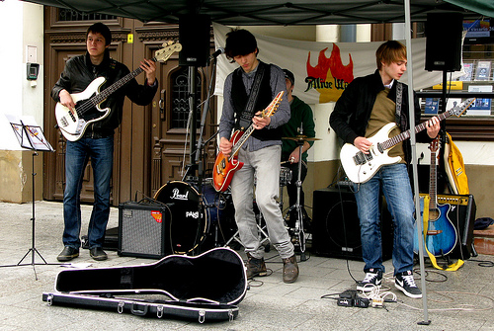
Andrius Mamontovas himself thinks that it would be great for the same tradition to spread in all over the world. The Street Music Day could become the only one day per year uniting everybody with an amazing kind of art – with the music which is an international language. Then all the evils, anger, aggression and frauds would be stopped for at least one day. Such a n even would beautify the world undoubtedly.
Photo: Street Music Day in Kedainiai, by Arnis, GVC1114 Photo: from http://www.flickr.com/photos/mysamstown/5703095109/

This good initiative helps people not only to have a good time, but also, to earn as listeners are often inclinable to donate some coins for performers. Musicians usually have upturned hats or open cases put nearby showing that they accept donation. And that is not illegal or unacceptable – it is just a fun part of the whole festival strengthening relations between musicians and listeners as well as motivating performers to perform as well as it is possible. Of course, this kind of tipping is not the purpose of the idea at all. It is just kind of appreciation of peoples` talents, work and good wills.
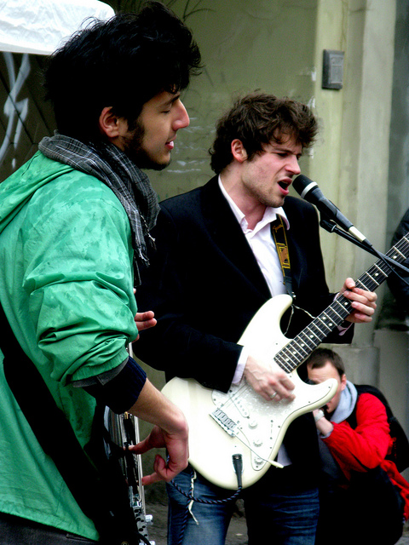

Photo: from http://www.flickr.com/photos/mysamstown/5703659418/in/photostream/

