Christmas Eve Miracles
Created by Monika&Eimantė,IIe, GVC1114

A country with a long pagan history and rich folk life, Lithuania has a wealth of age-old superstitions. According to Lithuanian folklore people believe that on Christmas Eve many miracles may occur.

People would take straw from under the table cloth, if it’s long – you can expect to have a long life, a short one – short life. Thick straw meant a rich and happy life.

A well of matches

On Christmas Eve, before you go to sleep you have to build a well by using matches and put it on a pillow. The first person in your dream that comes to drink some water from the well will be your beloved.

The upcoming year

On Christmas Eve take 4 small plates and flip them over. Under one of those put a candy, under the second one put a key, under the third one put a pen or eraser, and under the last one put a coin. Then somebody has to shuffle the plates and the other person has to choose a plate. If that someone finds a candy – he‘s going to eat a lot of sweets, the one that finds a key – will be sitting at home most of the time, the one that finds an eraser or a pen – is going to study hard, and the one that finds a coin – is going to get rich.

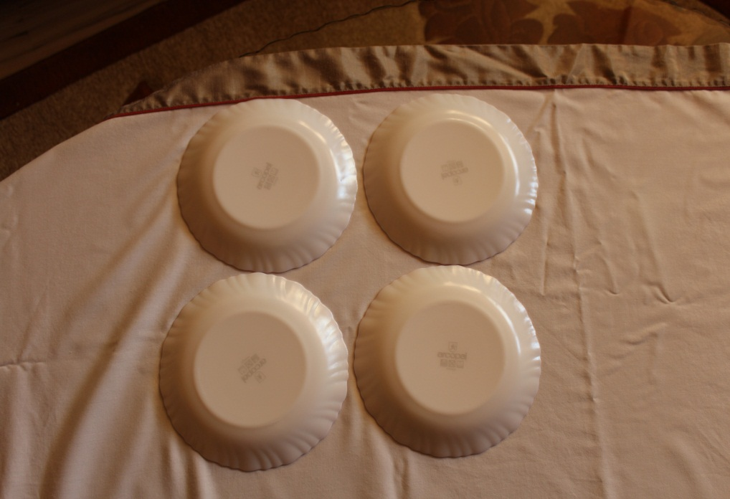

Photo: The upcoming year, by Monika&Eimantė, GVC1114
Photo: The upcoming year, by Monika&Eimantė, GVC1114

The dream that comes true

On Christmas Eve before going to sleep you have to pour some water in a cup and when you wake up in the morning you need to remember of what you have dreamt. If you remember it before looking into the window – the dream will come true. Just be careful – before all of this don‘t watch any horror movies.

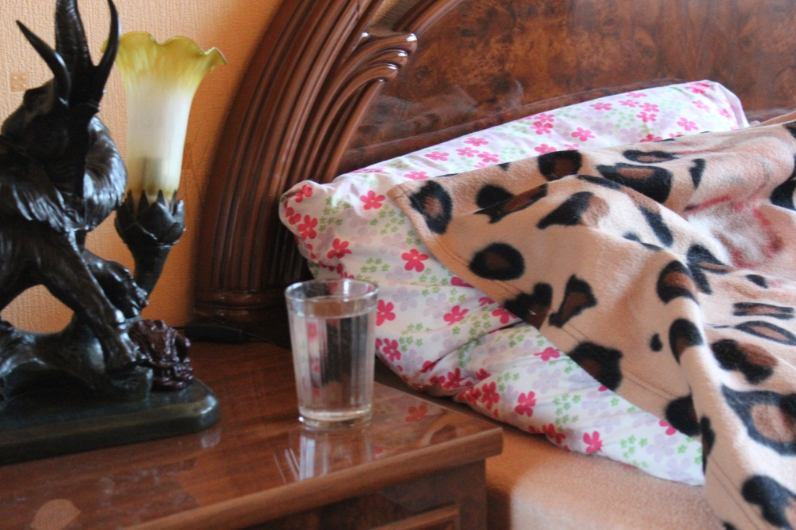
Photo: The dream that comes true, by Monika&Eimantė, GVC1114

Mysterious dream

Do you want to know if you have a secret admirer? On Christmas night everything is possible! By the way, before Christmas you have to get new combs. During the mysterious evening (Christmas Eve) brush your hair with new combs and put them under a fresh pillowcase. In the morning don‘t forget of what your dream was. Dreams are oracular and they will come true very soon.

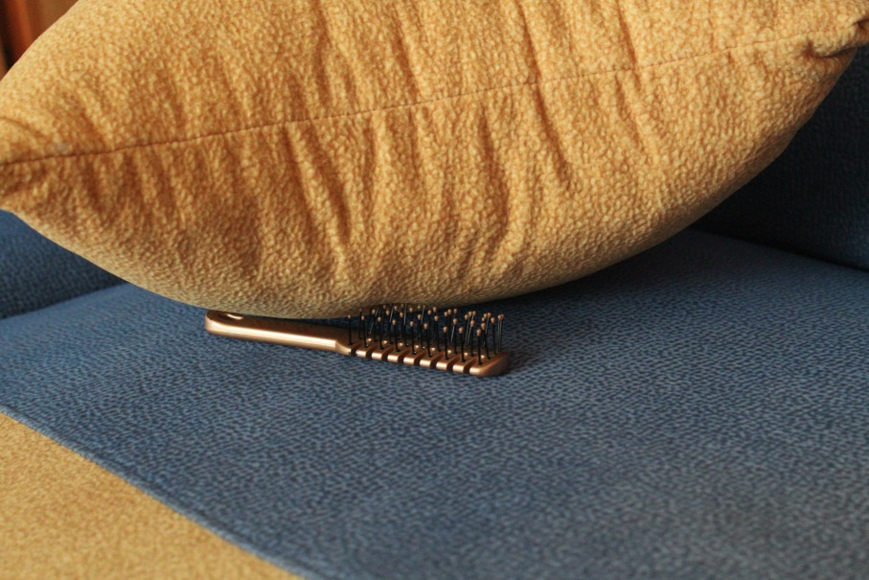

Photo: Mysterious dream, by Monika&Eimantė, GVC1114

Apple peelings

On Christmas Eve you have to bark apple peelings roundly and it shouldn‘t break. You need to throw the peelings above your head behind you. Depending on the position of dropped peeling, try to read a first letter of your beloved person.

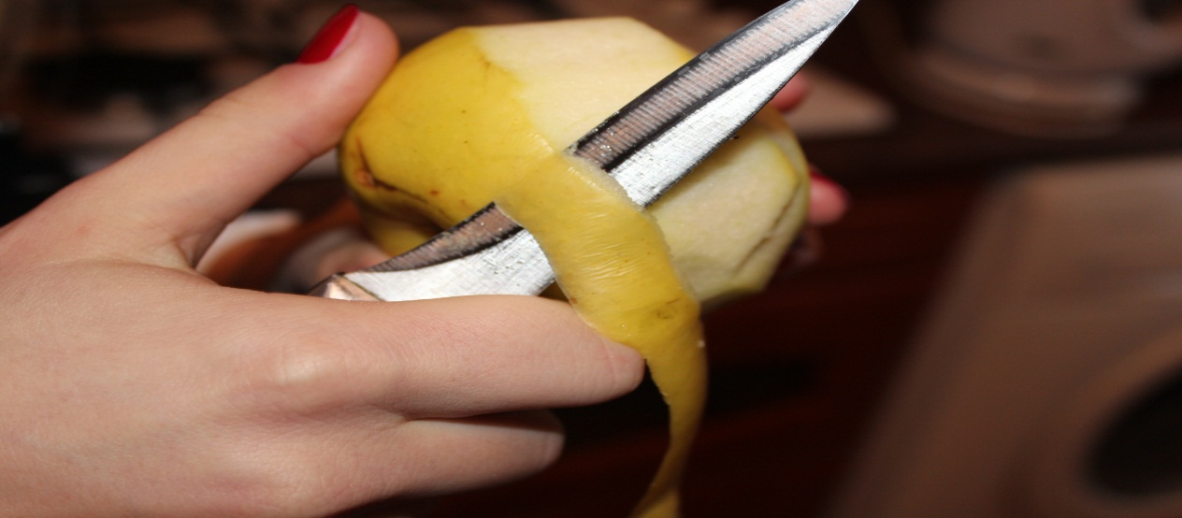
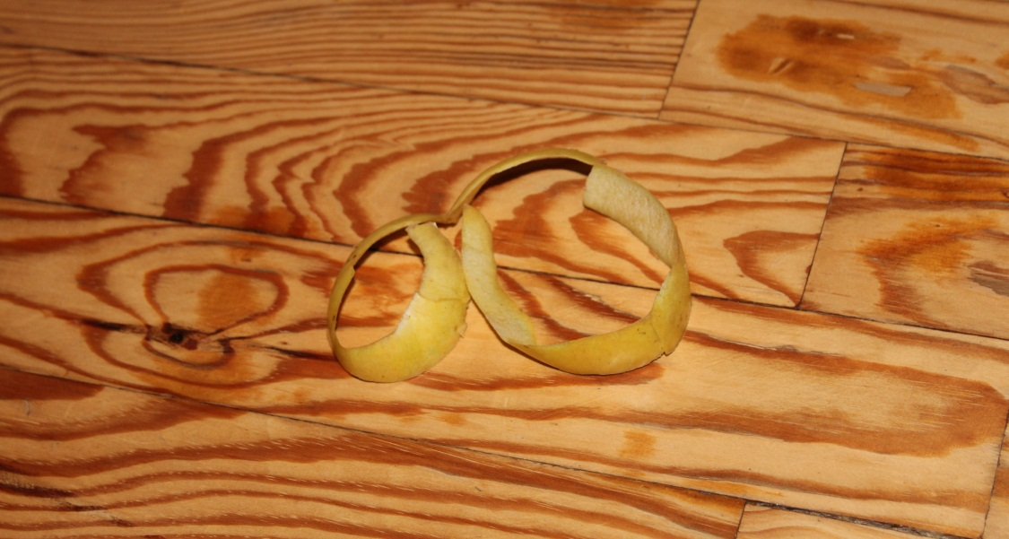
Photo: Apple peelings, by Monika&Eimantė, GVC1114

Ring

On Christmas Eve you have to take a bowl with water and you have to take a golden ring. While sitting in front of the mirror in the half-light you have to steep the ring three times in the water and look through the centre of it. You should see your future husband or wife.
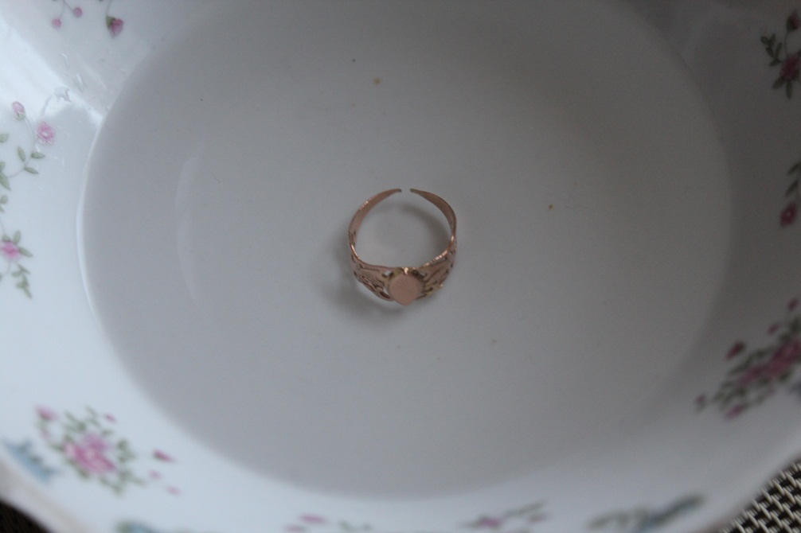

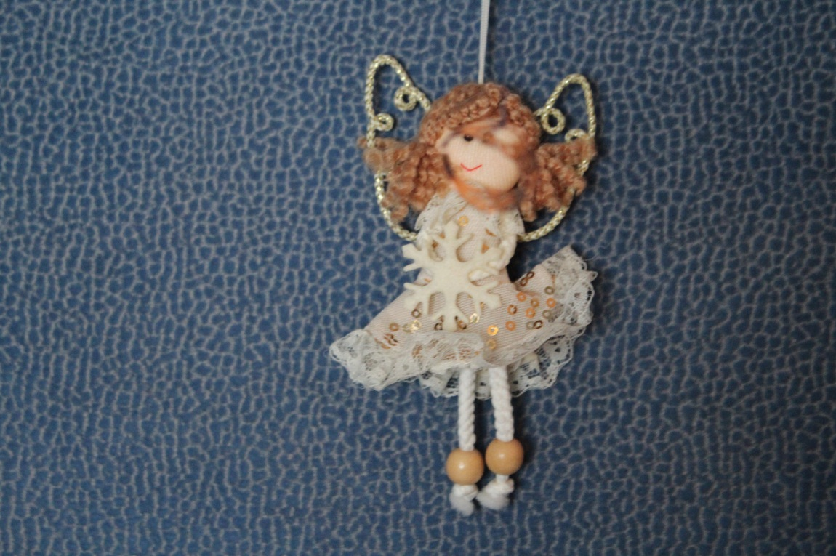
Photo: Ring, by Monika&Eimantė, GVC1114

10 wishes under the pillow

On Christmas Eve, before going to sleep on every sheet of paper (you need to have 10 of those) you have to write down one wish (it better be real). You can leave three leaflets empty to know that one of those wishes shouldn‘t come true. Those 10 leaflets got to be mixed and put under your pillow and on Christmas morning draw 3 leaflets without looking at them. Those three wishes will come true until the next Christmas.

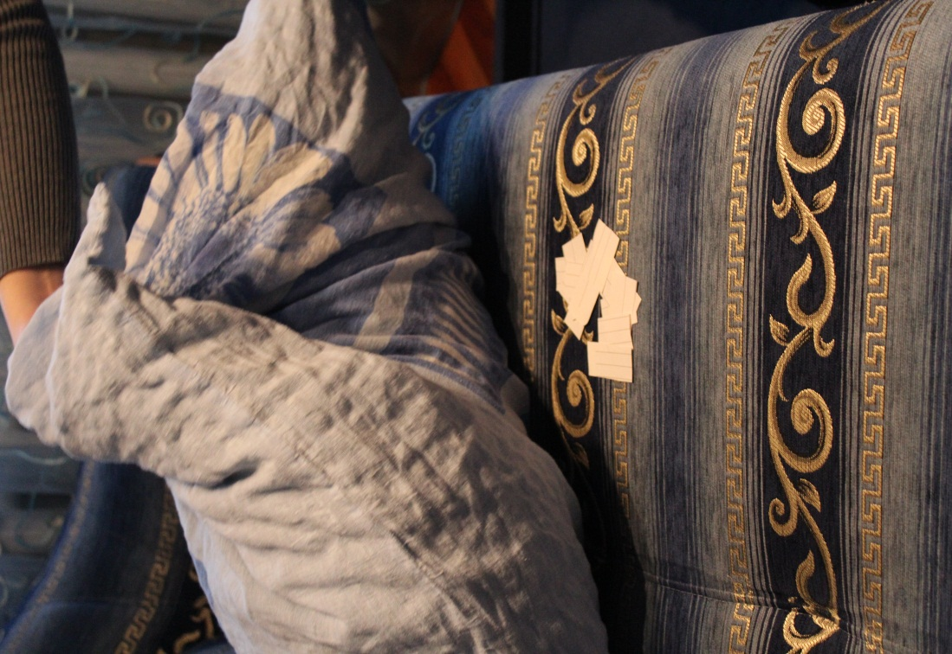

Photo: 10 wishes under the pillow, by Monika&Eimantė, GVC1114

Dogs bark

On Christmas Eve a girl has to go outside and listen in which direction the dogs are barking. Depending from which direction she will hear a dog barking from there her groom will come.

4 straws

You have to take 4 straws – 2 long and 2 short. After the midnight pull out one straw while thinking of a person you like. If you pull out the long one, he loves you, if short – not.

How to dream your lover

You have to do this whichcraft on Christmas Eve till the midnight.
1) You need to moisten your hair and brush it with wet comb.
2) Then go to sleep and put the wet comb under your bed.
3) In your dream while walking you will fall from the bridge and your lover will catch you.

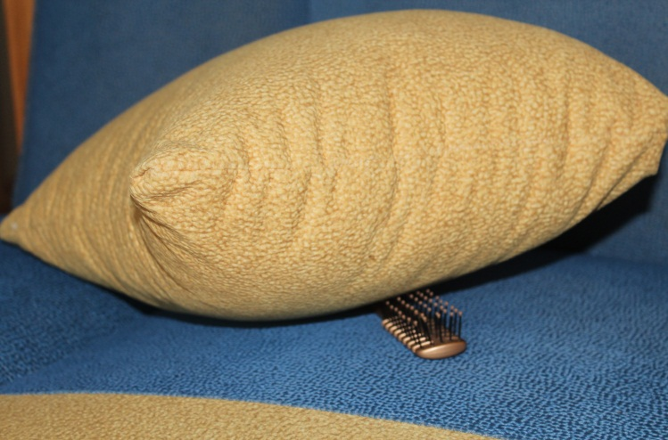
Photo: How to dream your lover?, by Monika&Eimantė, GVC1114

Shoes on Christmas Eve

On Chirstmas Eve take all the shoes out of the whole house and put them in a bag. Then you have to take them one by one and place them in a row by the door. Whose shoe will be the last, that person will be the first to move out of house.

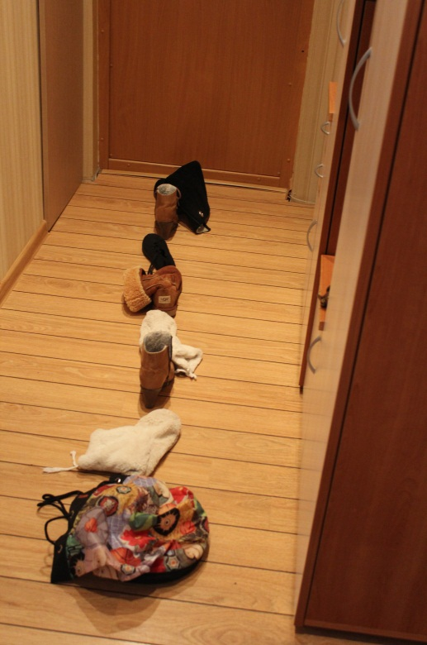
Photo: Shoes on Christmas Eve, by Monika&Eimantė, GVC1114

Finding love

On Christmas Eve boys and girls have to write their names on leaflets. Then put them into a bowl. Everyone has to pull out a leaflet.If a boy takes a leaflet with a girl‘s name they will be a couple.

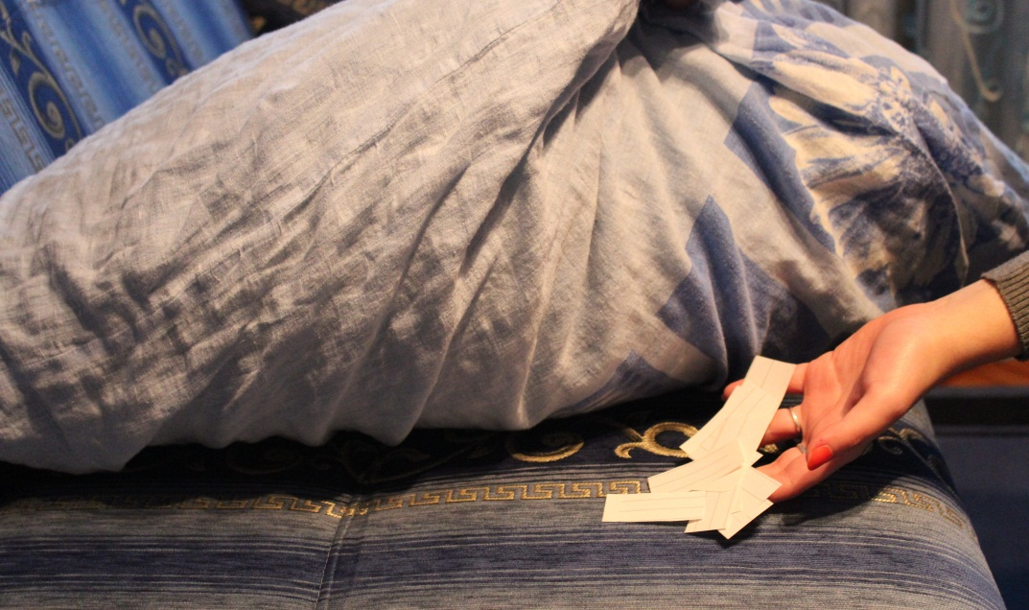
Photo: Finding love, by Monika&Eimantė, GVC1114

Spy your neighbours!

On Christmas Eve you need to listen to your neighbours at the door carefully, what they are talking about. If you hear – go – it means you will move out from your parents house (you will get married). If you hear – sit down- then you will stay at home. You can also interpret other words you hear too.

To have enough money.

On Christmas Eve put a hazelnut under your pillow. In Christmas morning put it in your wallet and you will always have money in it.

Will you get married or not?

On Christmas Eve you need to hug a fence. If the number of posts is even – you will get married, if odd – you need to wait for the next year.

Photo: Will you get merried or not?, by http://farm4.staticflickr.com/3392/3579380546_64d2ae60b2.jpg, GVC1114

Will your life last long?

On Christmas Eve you have to put hay under the tablecloth. Every family member pulls out 1 straw. The longer the straw, the longer your life.

Photo: Will your life last long?, by http://farm3.staticflickr.com/2643/4216269232_46af877c0e.jpg, GVC1114

People would take straw from under the tablecloth, if it’s long – you can expect to have a long life, a short one – short life. Thick straw meant a rich and happy life.

Will you find a lover?

Girls take Christmas Eve cookies and count how much they have taken. If a number is even – then yes, if odd, then they will not find a lover. After this procedure you have to eat the cookies.

Shoes

Stand in a row and everyone throws a shoe over his left shoulder. If a shoe turns to the door side – you will get married soon.
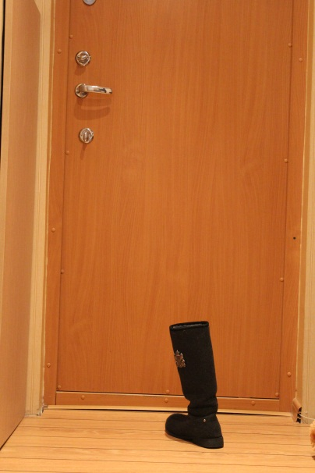
Photo: Shoes, by Monika&Eimantė, GVC1114

Divination by using a mirror

On Christmas Eve before you go to sleep put a mirror under your pillow. Everything you are going to dream at night is going to come true.

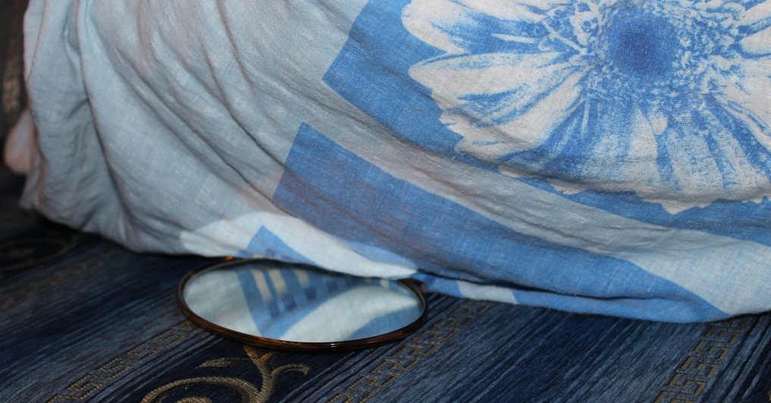

Photo: Divination by using a mirror, by Monika&Eimantė, GVC1114

Created by Monika&Eimantė

