The material was prepared by Paulina(IIIc),Gintare(IIIc),Lauryna(IIe),Raminta(IIe),Greta(IIIg)

Lithuanian Christmas Decorations
Lithuanian Christmas traditions are a combination of old and new and Christian and pagan, and they have similarities with traditions from the other two Baltic nations.
Handmade straw ornaments are particularly traditional. They can decorate Christmas trees or be used as decoration for other parts of the house.
The custom of decorating a fir tree and the giving of presents became part of the Lithuanian Christmas tradition after World War I, having adopted it from Germany.
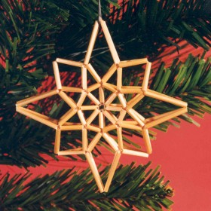  http://ramute-plioplys.com/main.php/v/Christmas+ornaments/ | 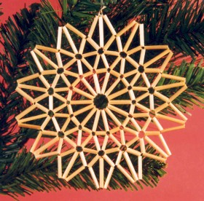  http://ramute-plioplys.com/main.php/v/Christmas+ornaments/
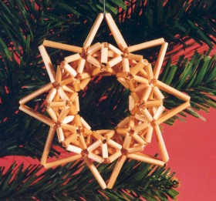
http://ramute-plioplys.com/main.php/v/Christmas+ornaments/

Here are images from the site that illustrate the process of creating triangular shapes, the basic foundation of the ornaments:
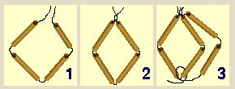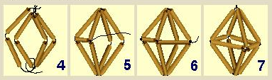
Putting together the shapes to create lanterns, stars and other patterns they can finish simple.

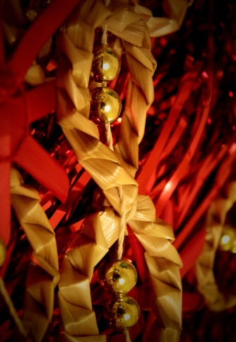  Photo:Straw ornament, by Lauryna,GVC1114 | 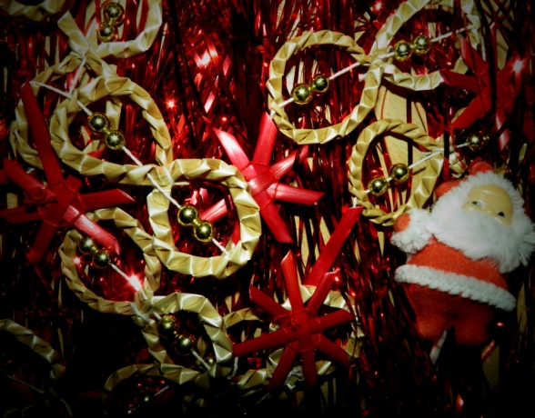  Photo:Straw ornament, by Lauryna,GVC1114
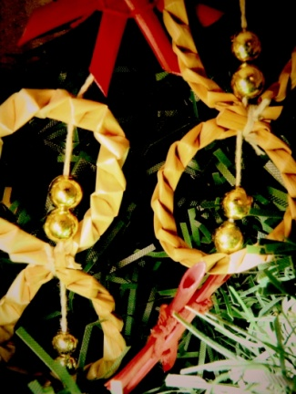  Photo:Straw ornament, by Lauryna,GVC1114 | 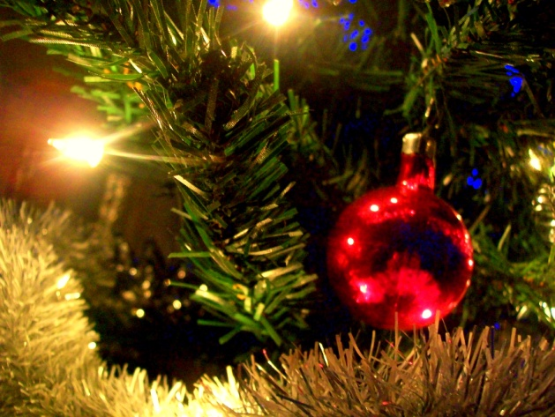  Photo:Decoration, byRaminta,GVC1114
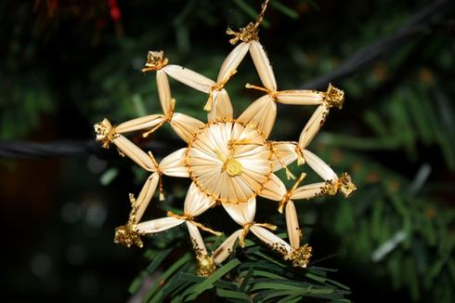  Photo:  Star, by Paulina, GVC1114  2011.12.09 | 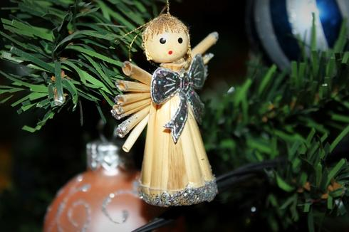  Photo:  Star, by Gintare, GVC1114  2011.12.09
It was typical to have Christmas decorations made of glass. Usually our grandparents have such Christmas decorations
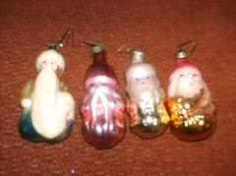  Photo:Christmas decoration-glass,by Greta,GVC1114 | 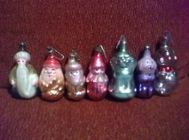  Photo:Christmas decoration-glass,by Greta,GVC1114
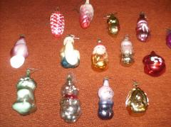  Photo:Christmas decoration-glass,byGreta,GVC1114 | 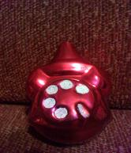  Photo:Christmas decoration-glass,byGreta,GVC1114
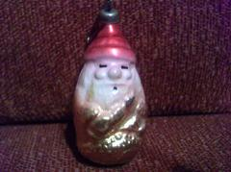  Photo:Christmas decoration-glass,byGreta,GVC1114 | 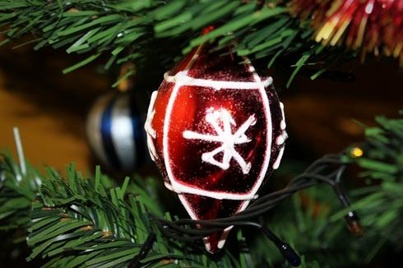  Photo:  Star, by Paulina, GVC1114  2011.12.09
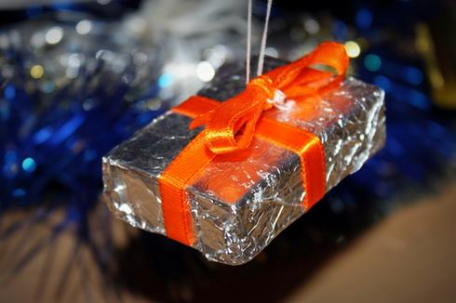  Photo:  Star, by Gintare, GVC1114  2011.12.09 | Photo:Decoration, byRaminta,GVC1114
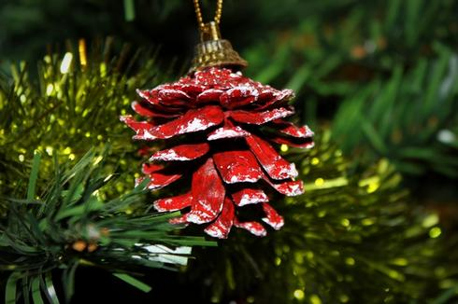
Photo:
Star, by Gintare, GVC1114
2011.12.09

Christmas trees in Lithuania
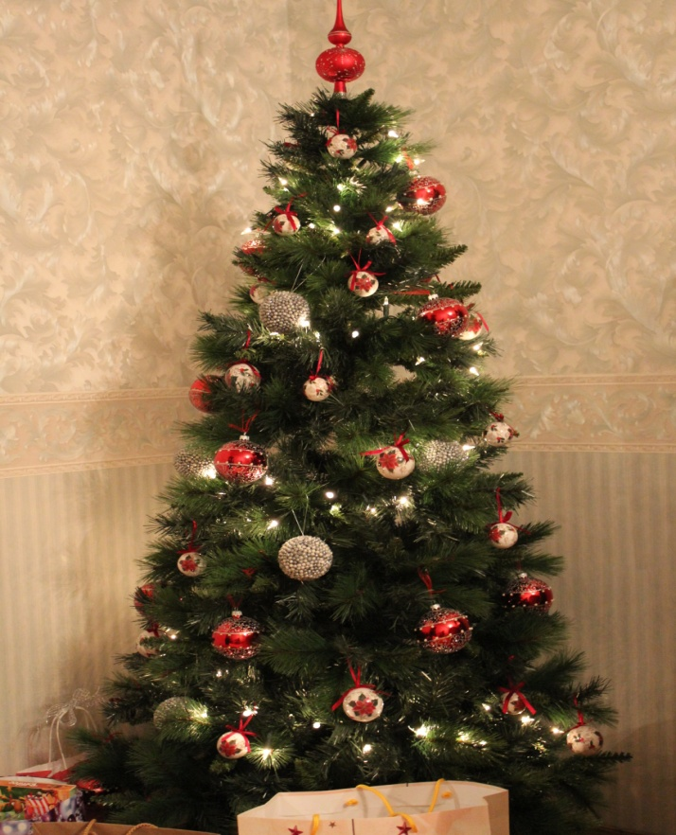
Christmas tree 2012,by Eimante,GVC1114

http://portal.sliderocket.com/BJMRX/Christmas-decoration

